**Assignment 2**

**Work Progress**

19/11/2021

COS10004

NGO CONG THANH

Assignment Program Model:

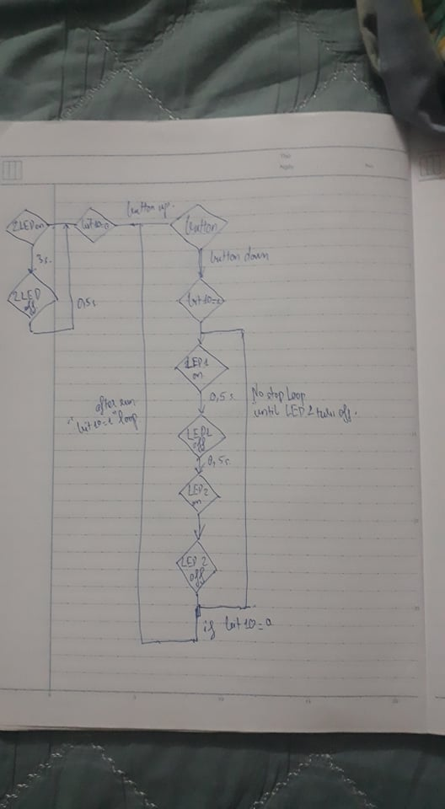

**Main.asm:**

macro delay {

local .wait

mov r2,#0x3F0000

.wait:

sub r2,#1

cmp r2,#0

bne .wait

}

BASE = $FE000000 ; Use $3F000000 for 2B, 3B, 3B+

GPIO_OFFSET = $200000

mov r0,BASE

orr r0,GPIO_OFFSET ;Base address of GPIO

ldr r1,[r0,#4] ;read function register for GPIO 10 - 19

;clear the 3 bits for GPIO10

bic r1,r1,#7 ;bit clear

str r1,[r0,#4]

;output set up GPIO 17 18

mov r8,#9

lsl r8,#21

str r8,[r0,#8]

;setvalue

mov r8,#1

lsl,#17

mov r4,#1

lsl r4,#18

;Turn on and off LED base on cont

include "Timer.asm"

**Timer.asm:**

TIMER:

TIMER_OFFSET = $3000

;TIMER_MICROSECONDS = 524288 ; $0080000 ;0.524288 s

orr r3,TIMER_OFFSET ;store base address of timer (r3)

mov r4,$70000

orr r4,$0A100

orr r4,$00020 ;TIMER_MICROSECONDS = 500,000

ldrd r6,r7,[r3,#4]

mov r5,r6 ;store starttime (r5)(=currenttime (r6))

timerloop:

ldrd r6,r7,[r3,#4] ;read currenttime (r6)

sub r8,r6,r5 ;remainingtime (8)= currenttime (r6) - starttime (r5)

cmp r8,r4 ;compare remainingtime (r8), delay (r4)

bls timerloop

bx lr